**Module 13 – Challenge Lab: Implementing a Serverless Architecture for the Café**

### Task 1: Downloading the source code

Answer the question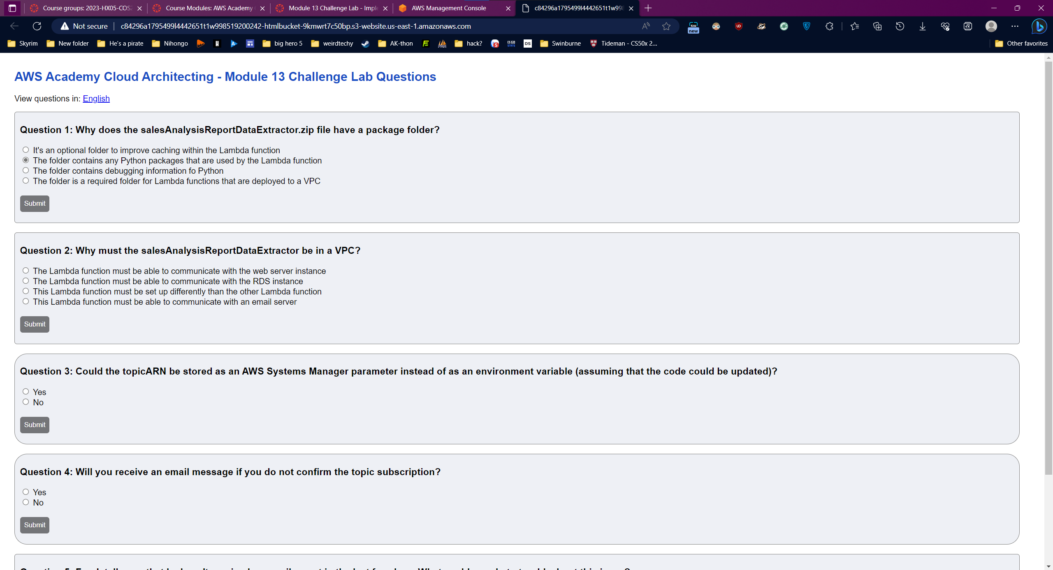

### Task 2: Creating the DataExtractor Lambda function in the VPC

### Create a security group for the Lambda function with the following settings:

* + **Security group name**: LambdaSG
  + **VPC**: *Lab VPC*
  + **Outbound Rules**: *All traffic* to all addresses

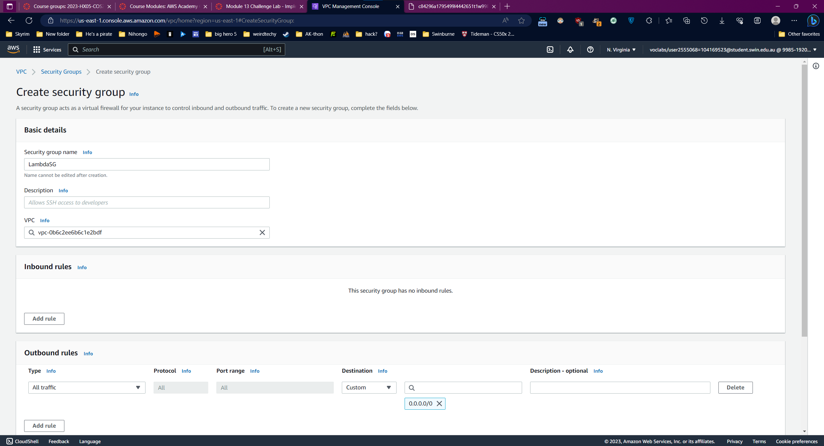

Update the DatabaseSG security group.

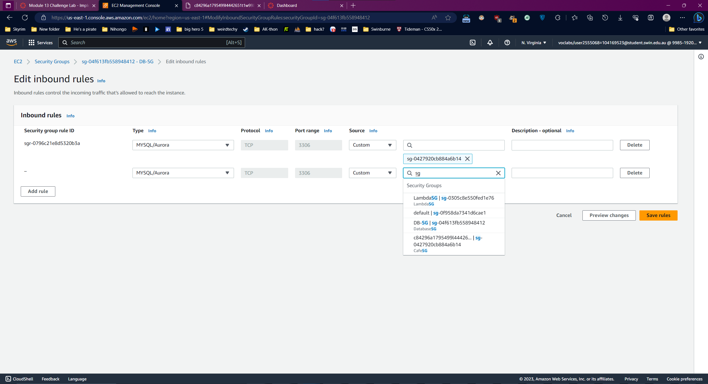

Create Lambda Function

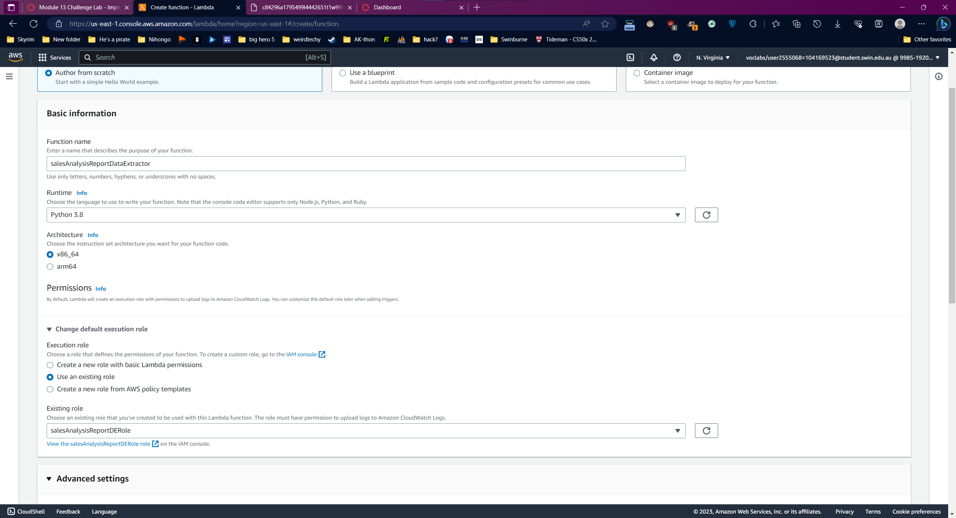

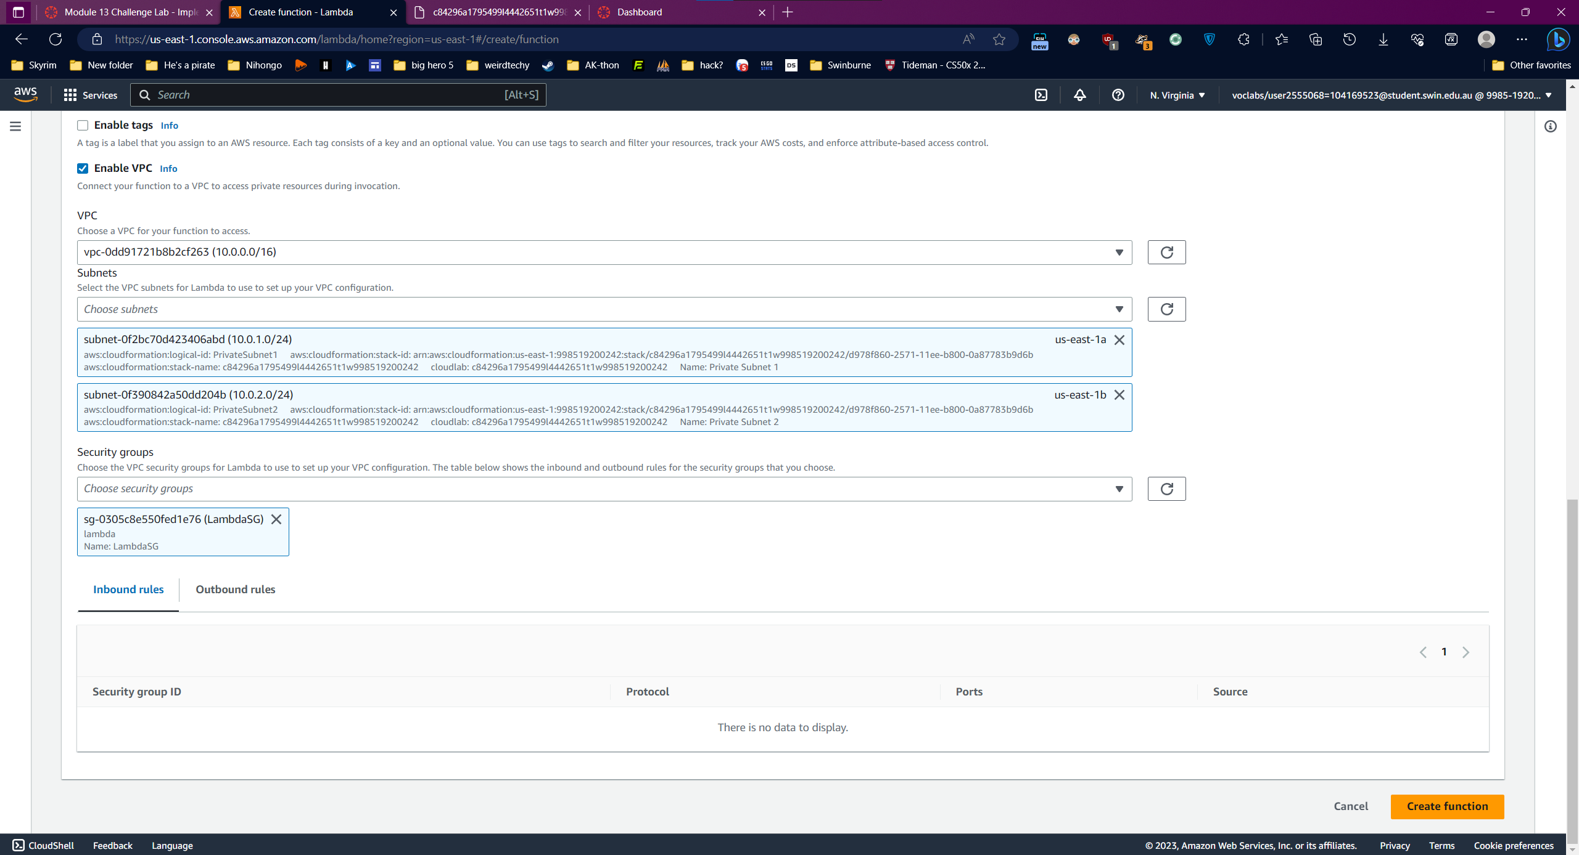

Upload Code

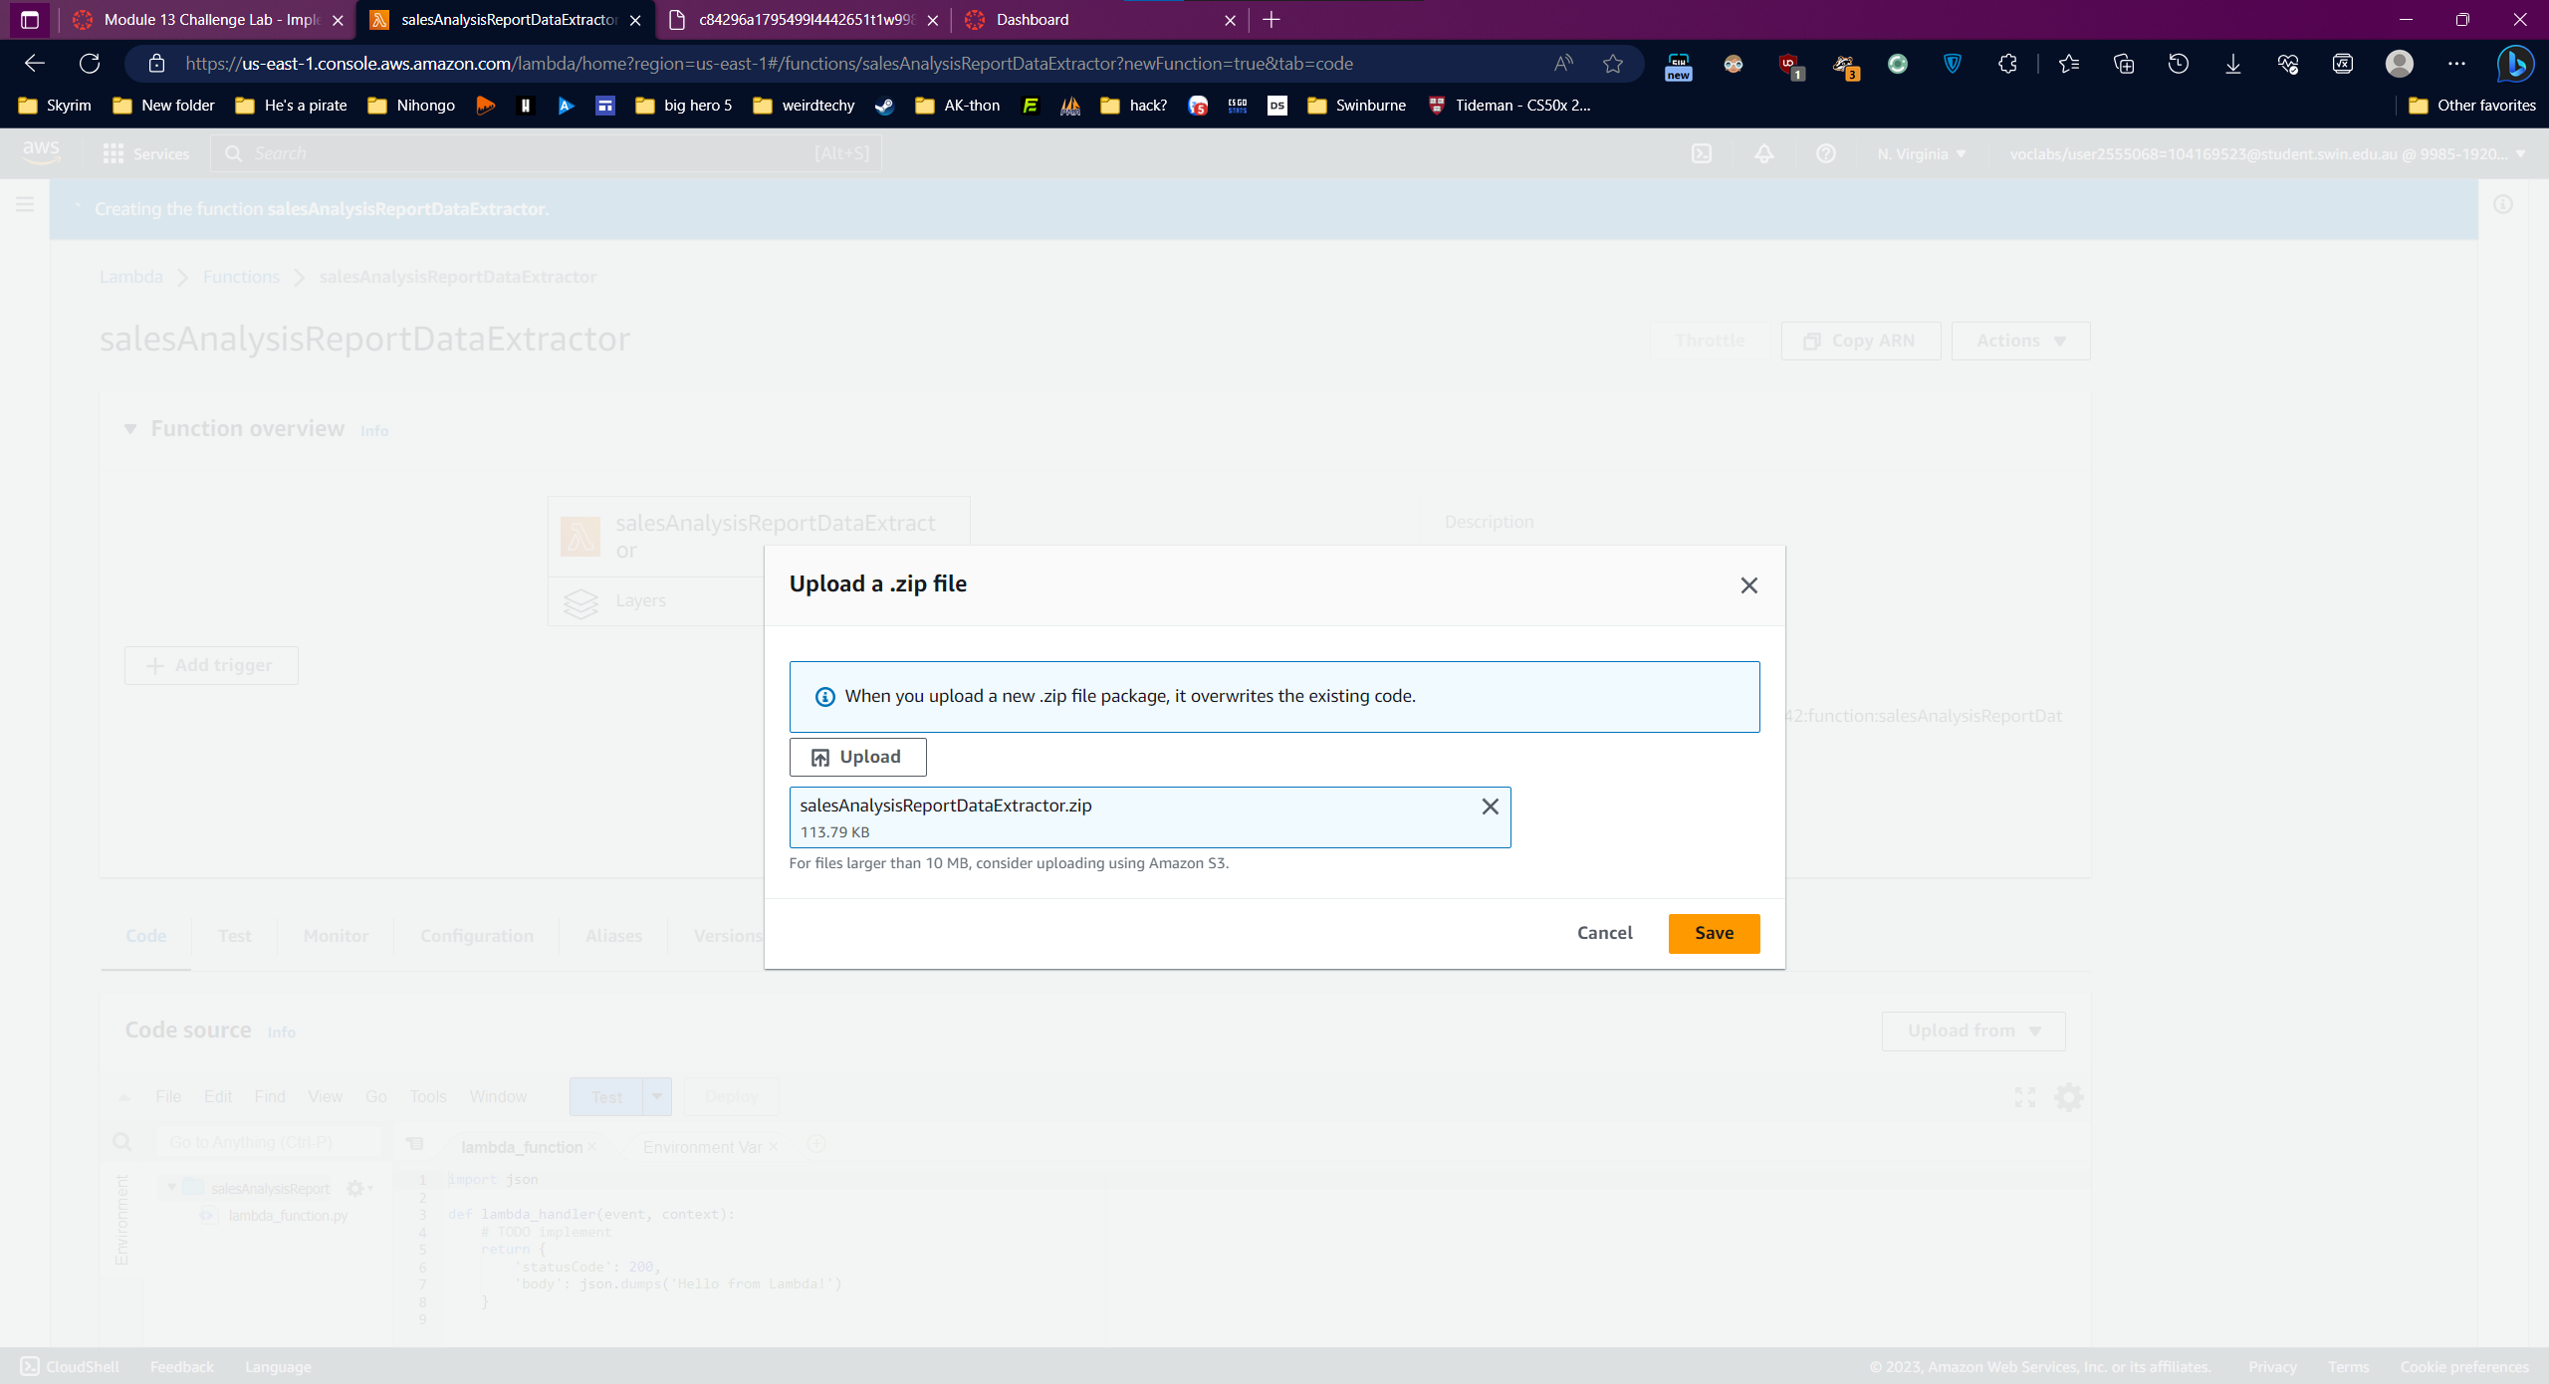

Edit settings

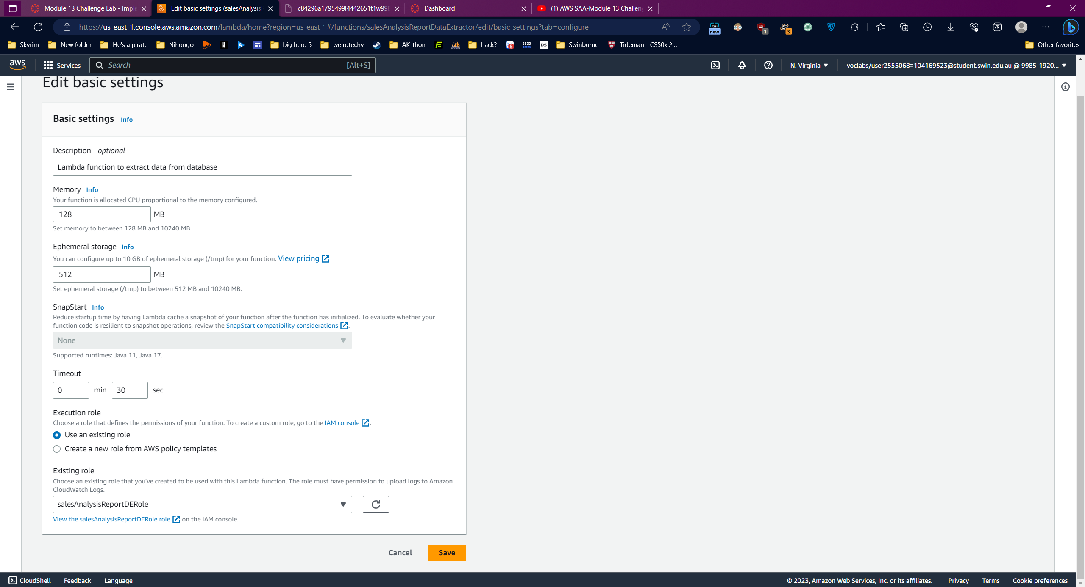

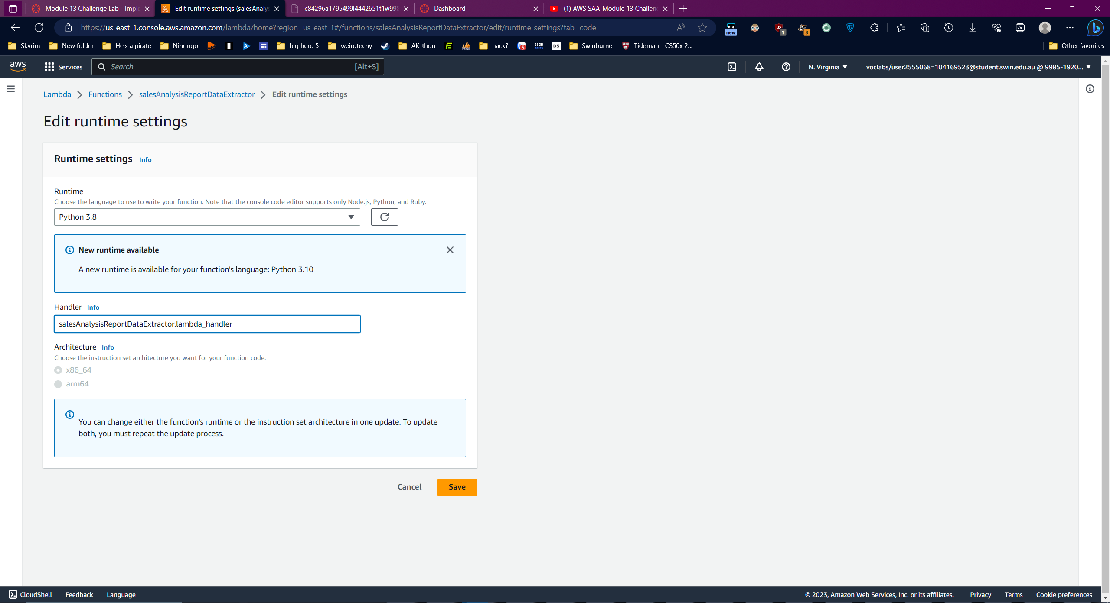

Question 2:

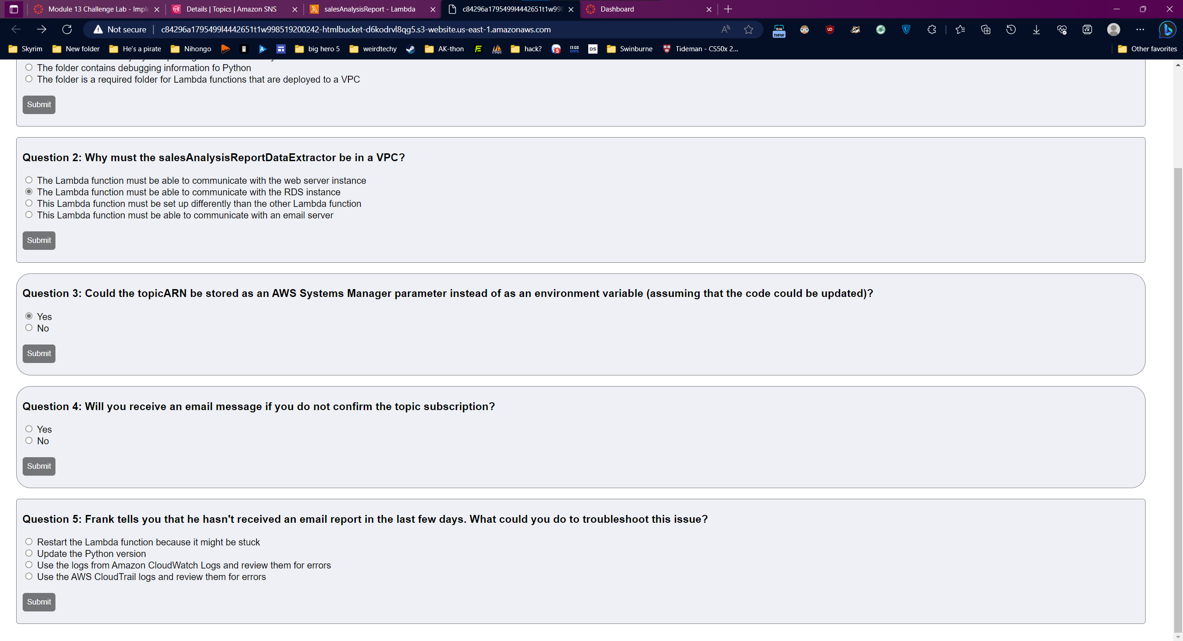

### Task 3: Creating the salesAnalysisReport Lambda function

Create another function

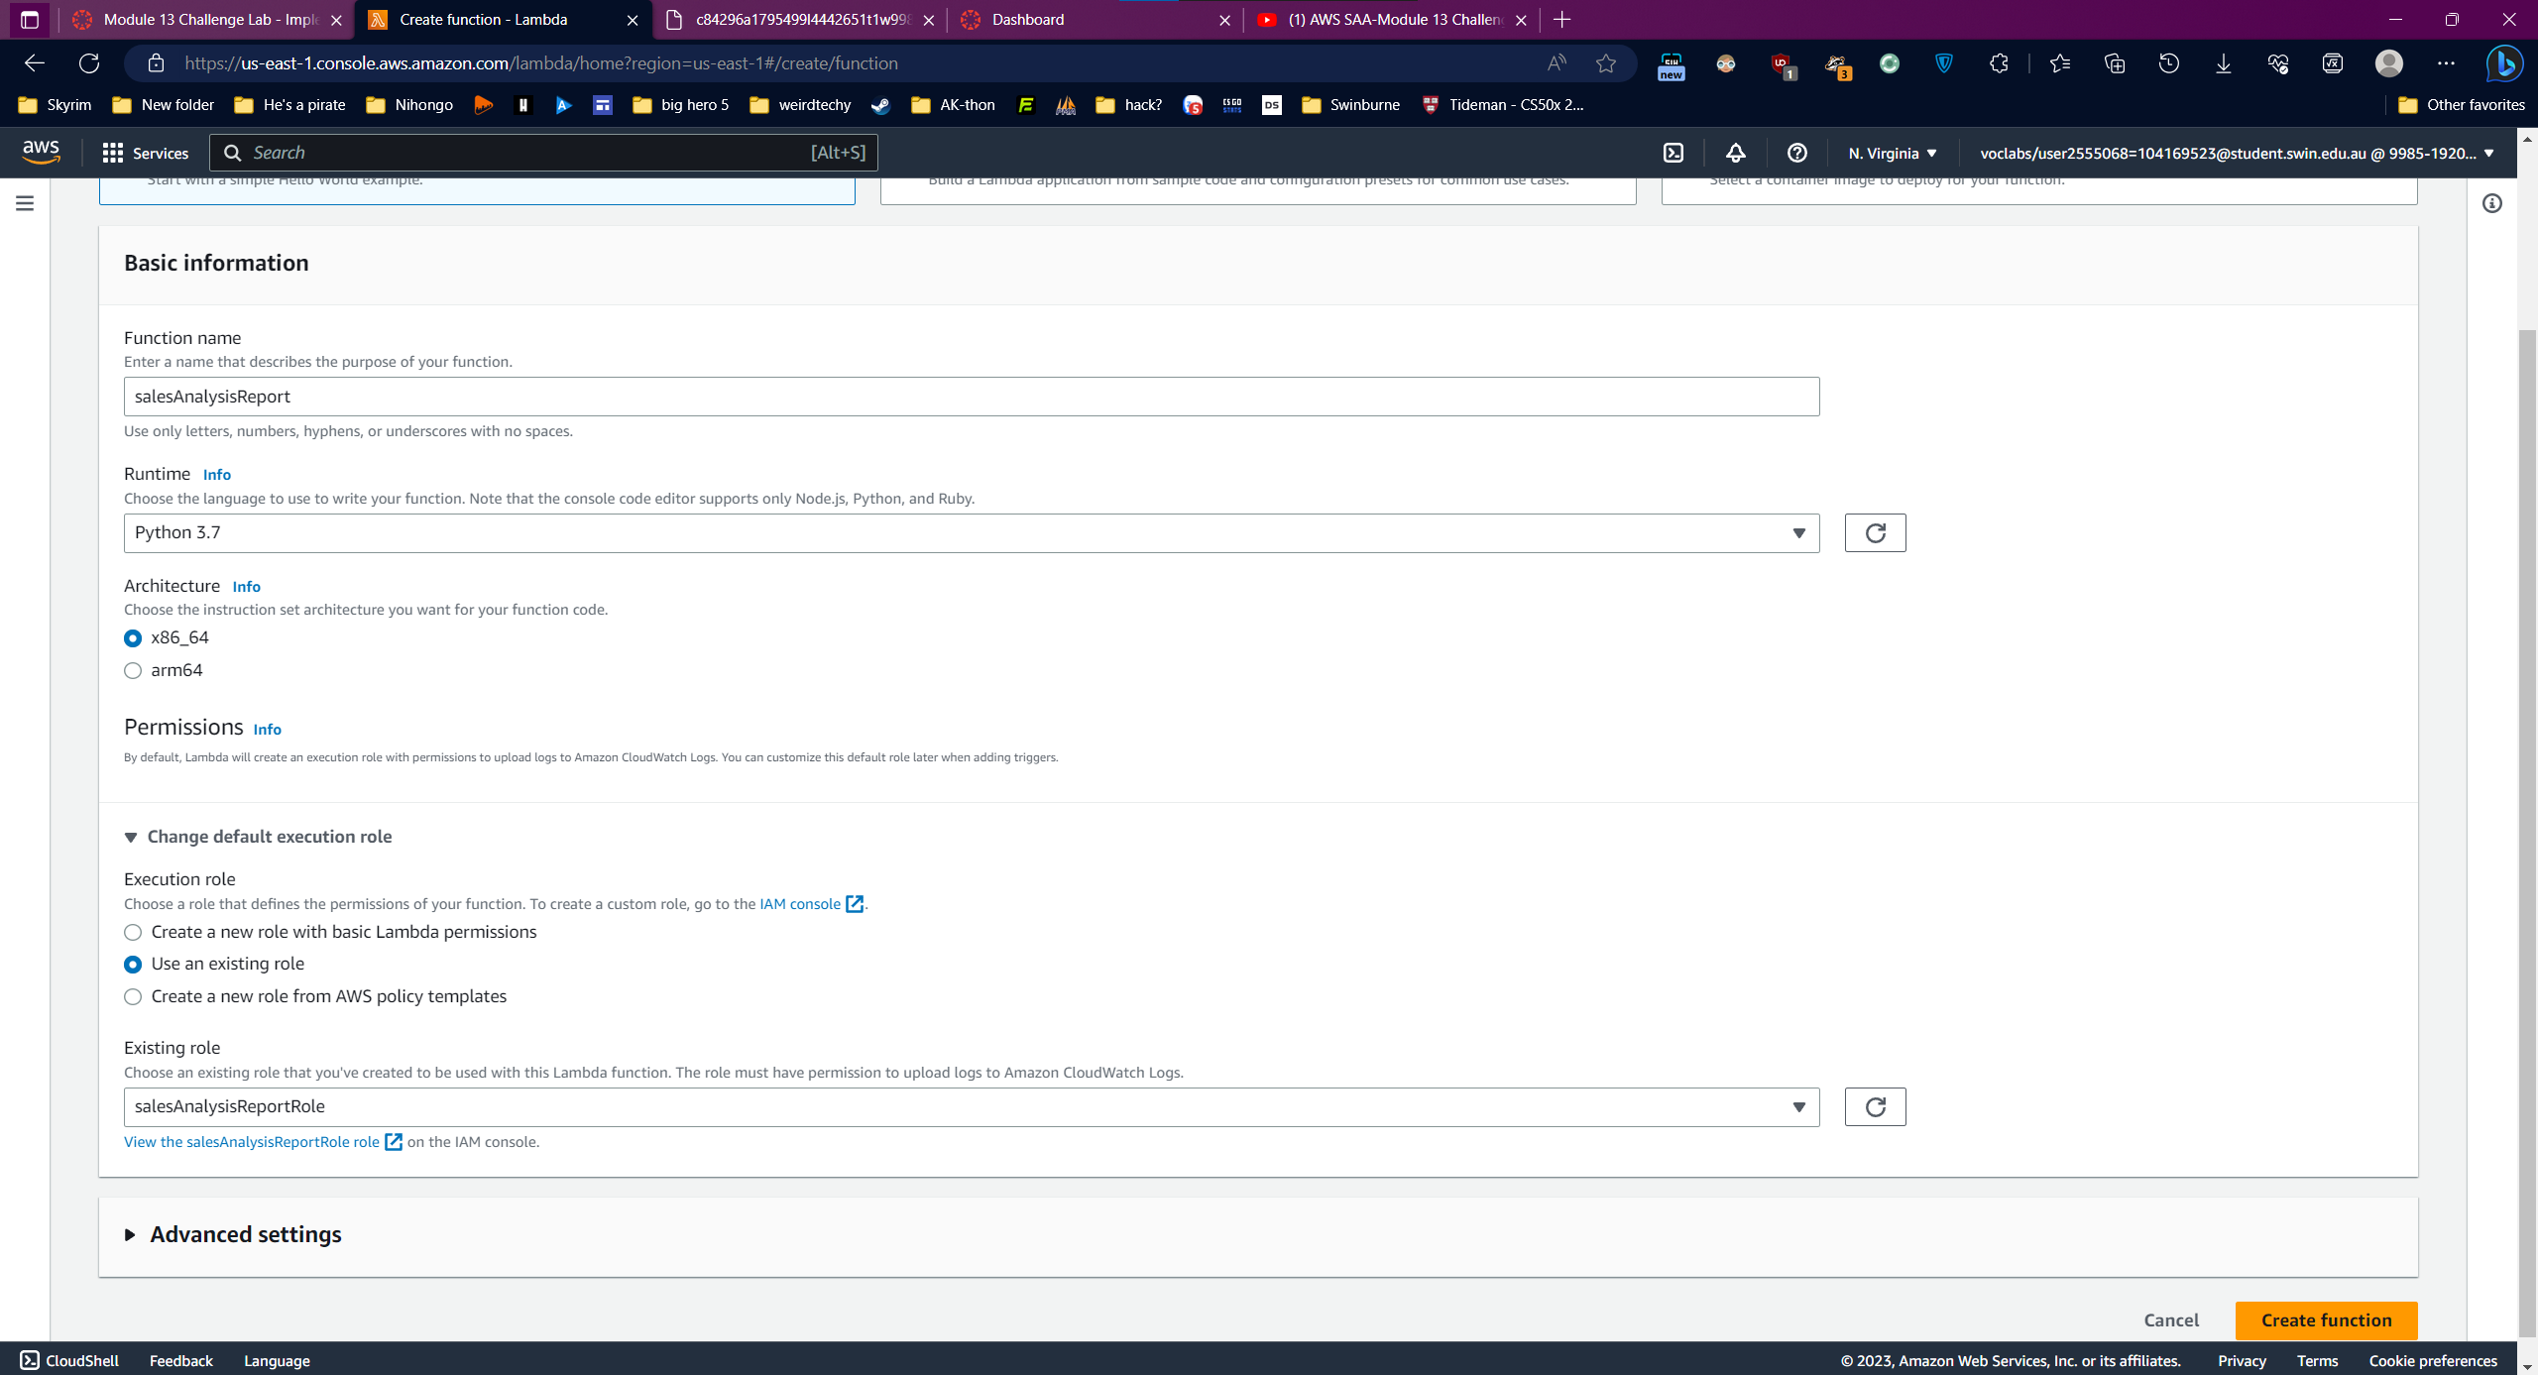

Upload code

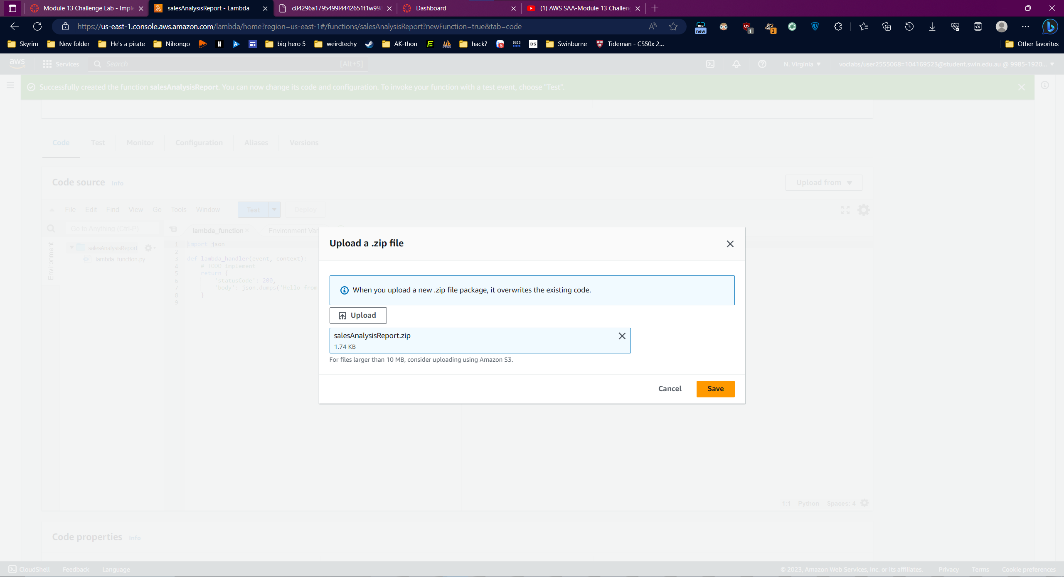

Change settings

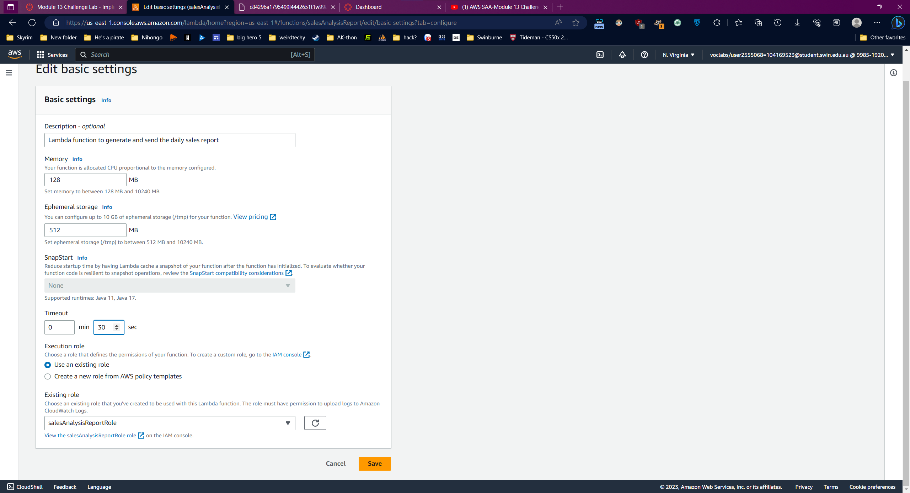

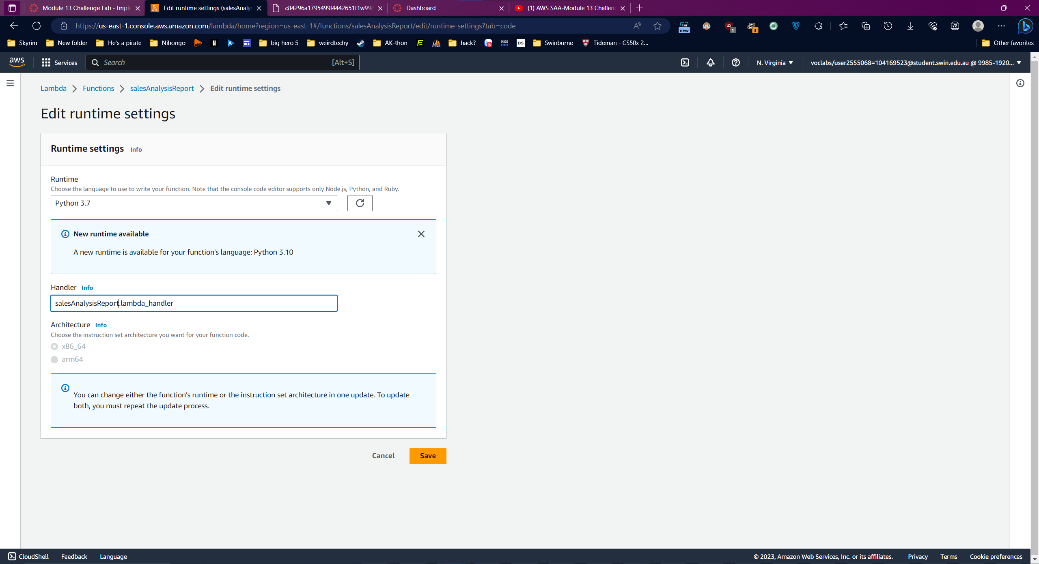

### Task 4: Creating an SNS topic

Create a topic

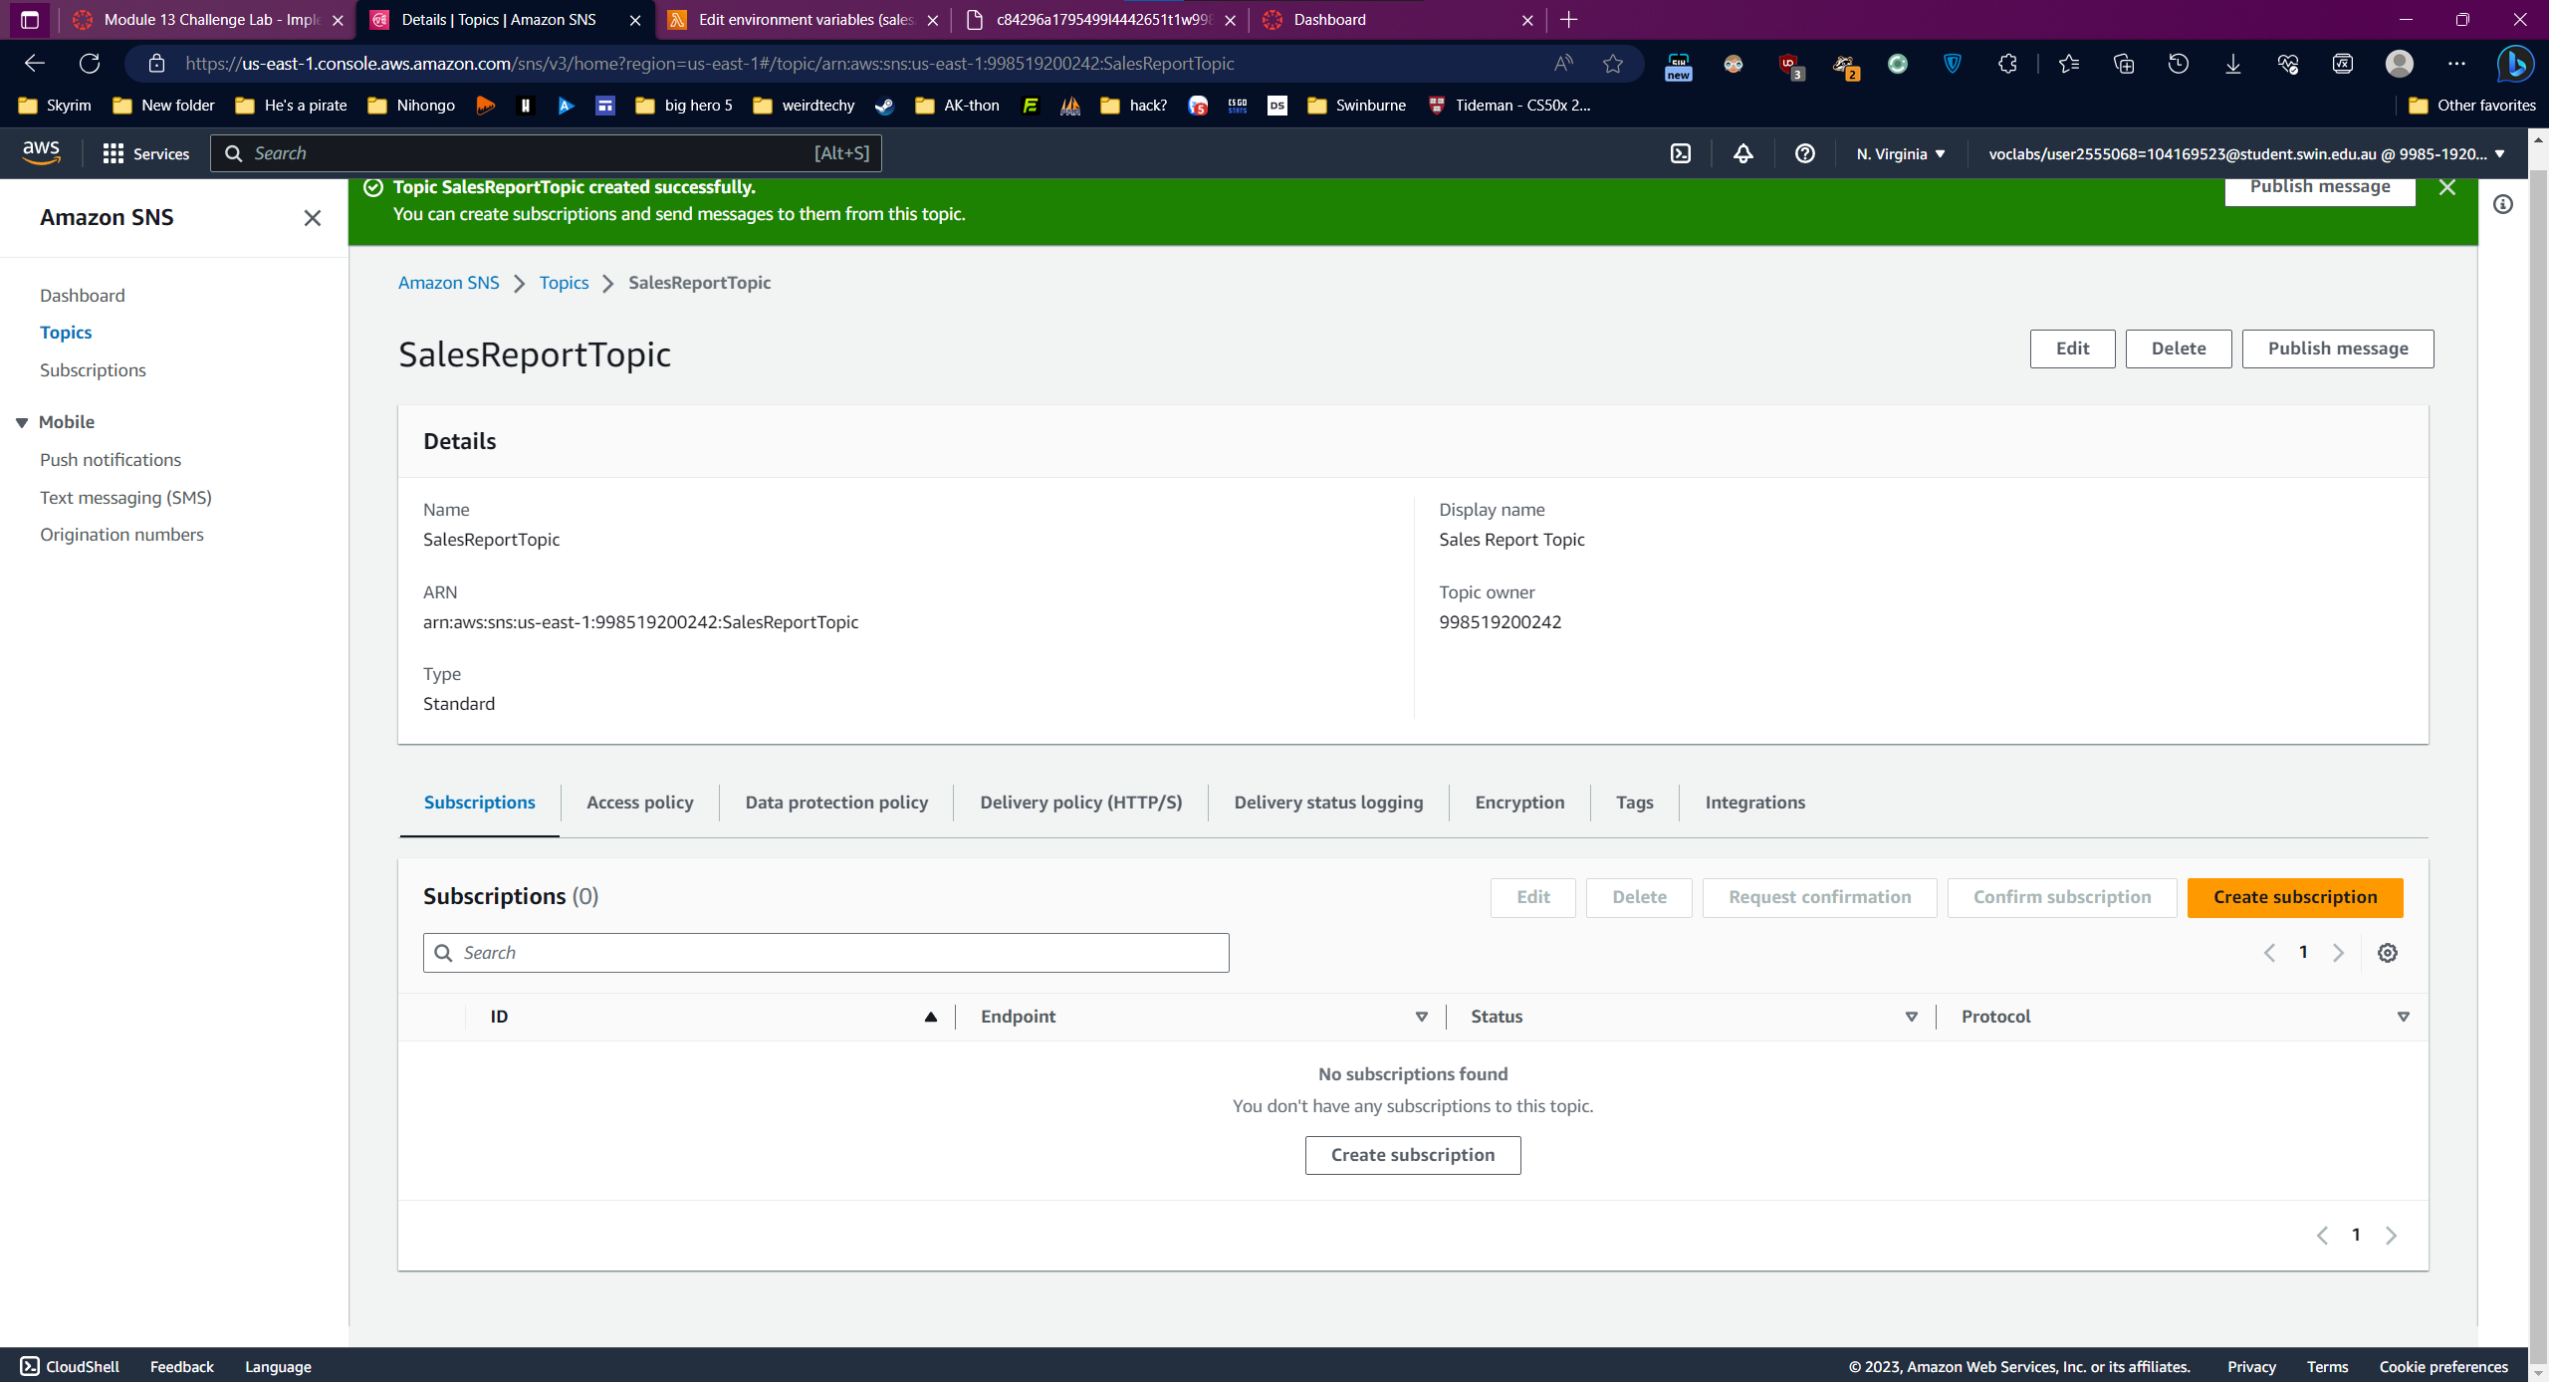

Add an environment variables

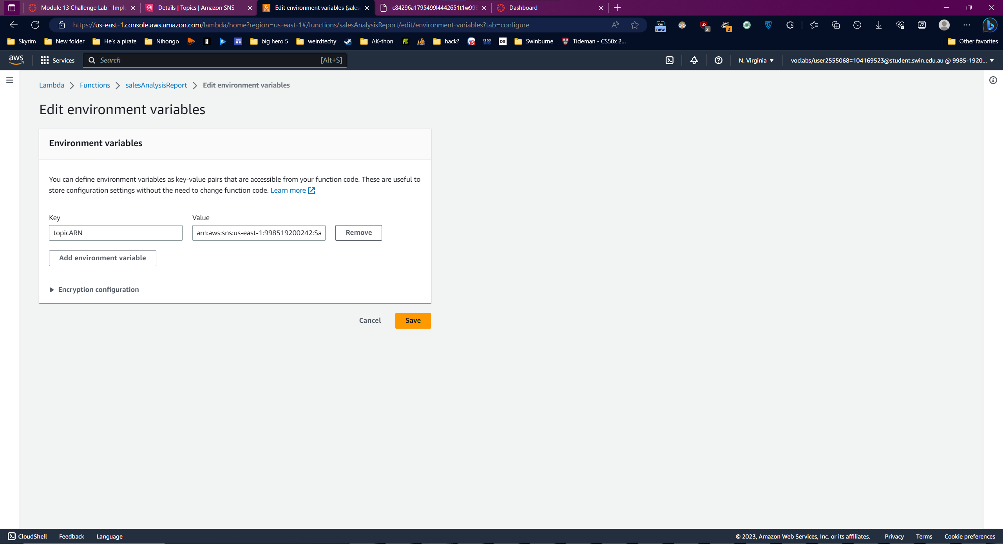

Question 3



### Task 5: Creating an email subscription to the SNS topic

Create Subscription

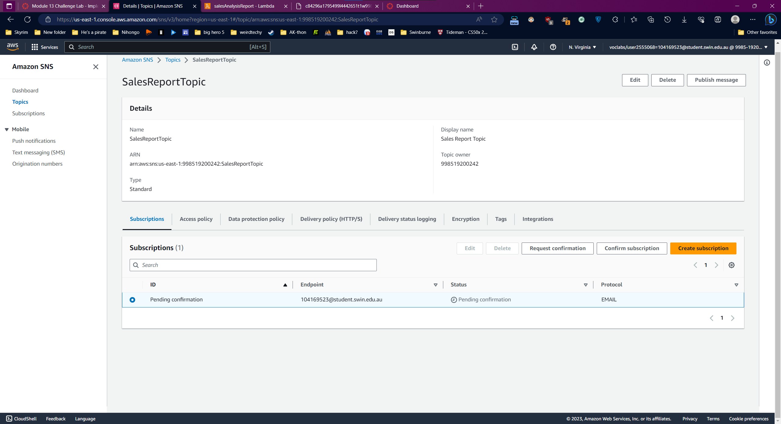

Confirm

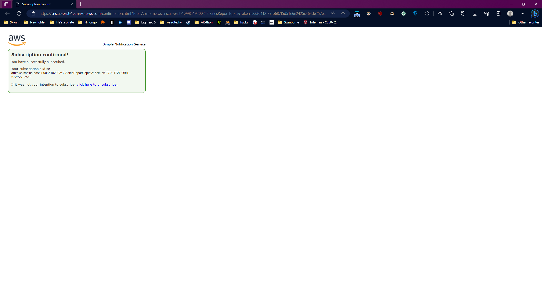

Question 4:

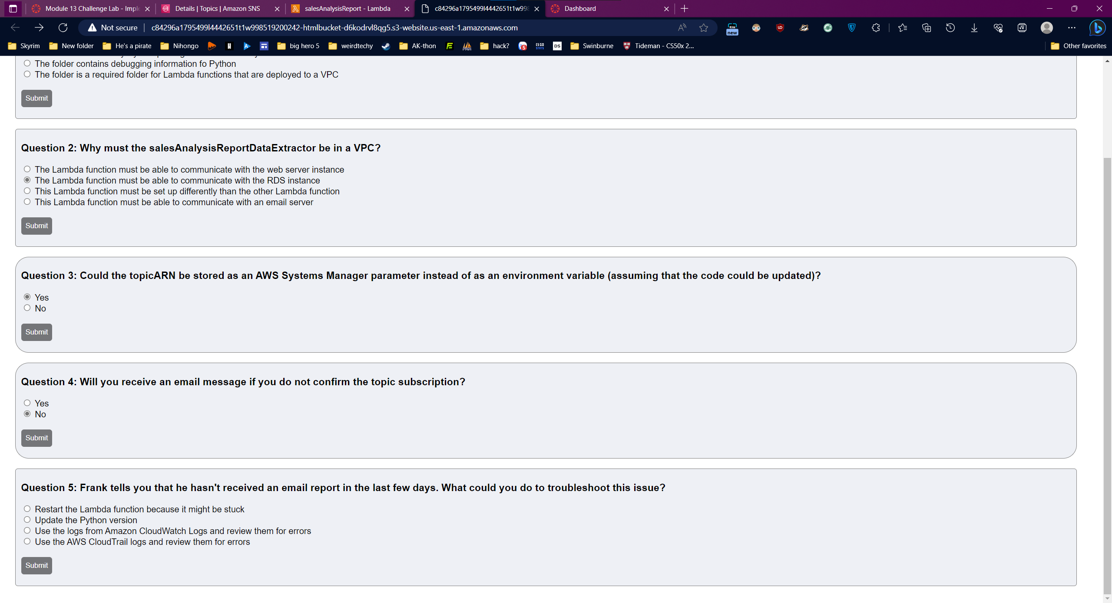

### Task 6: Testing the salesAnalysisReport Lambda function

Create a Test:

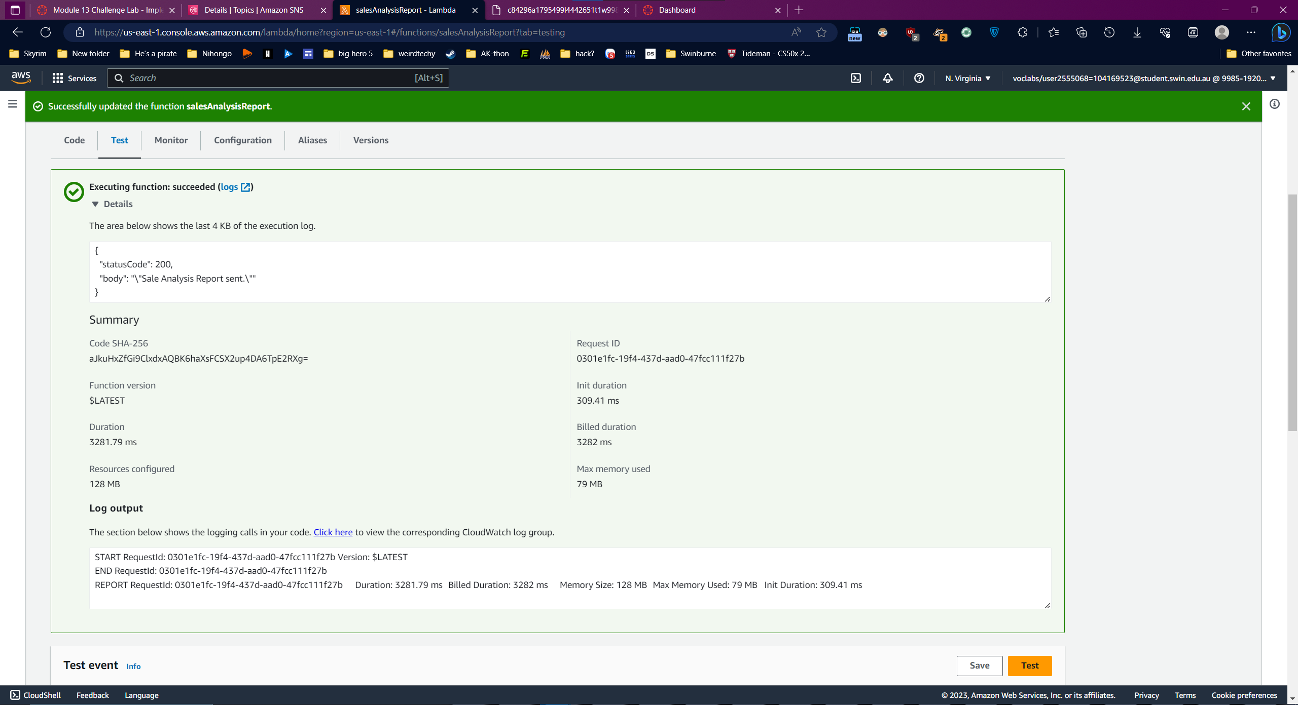

Email notification:

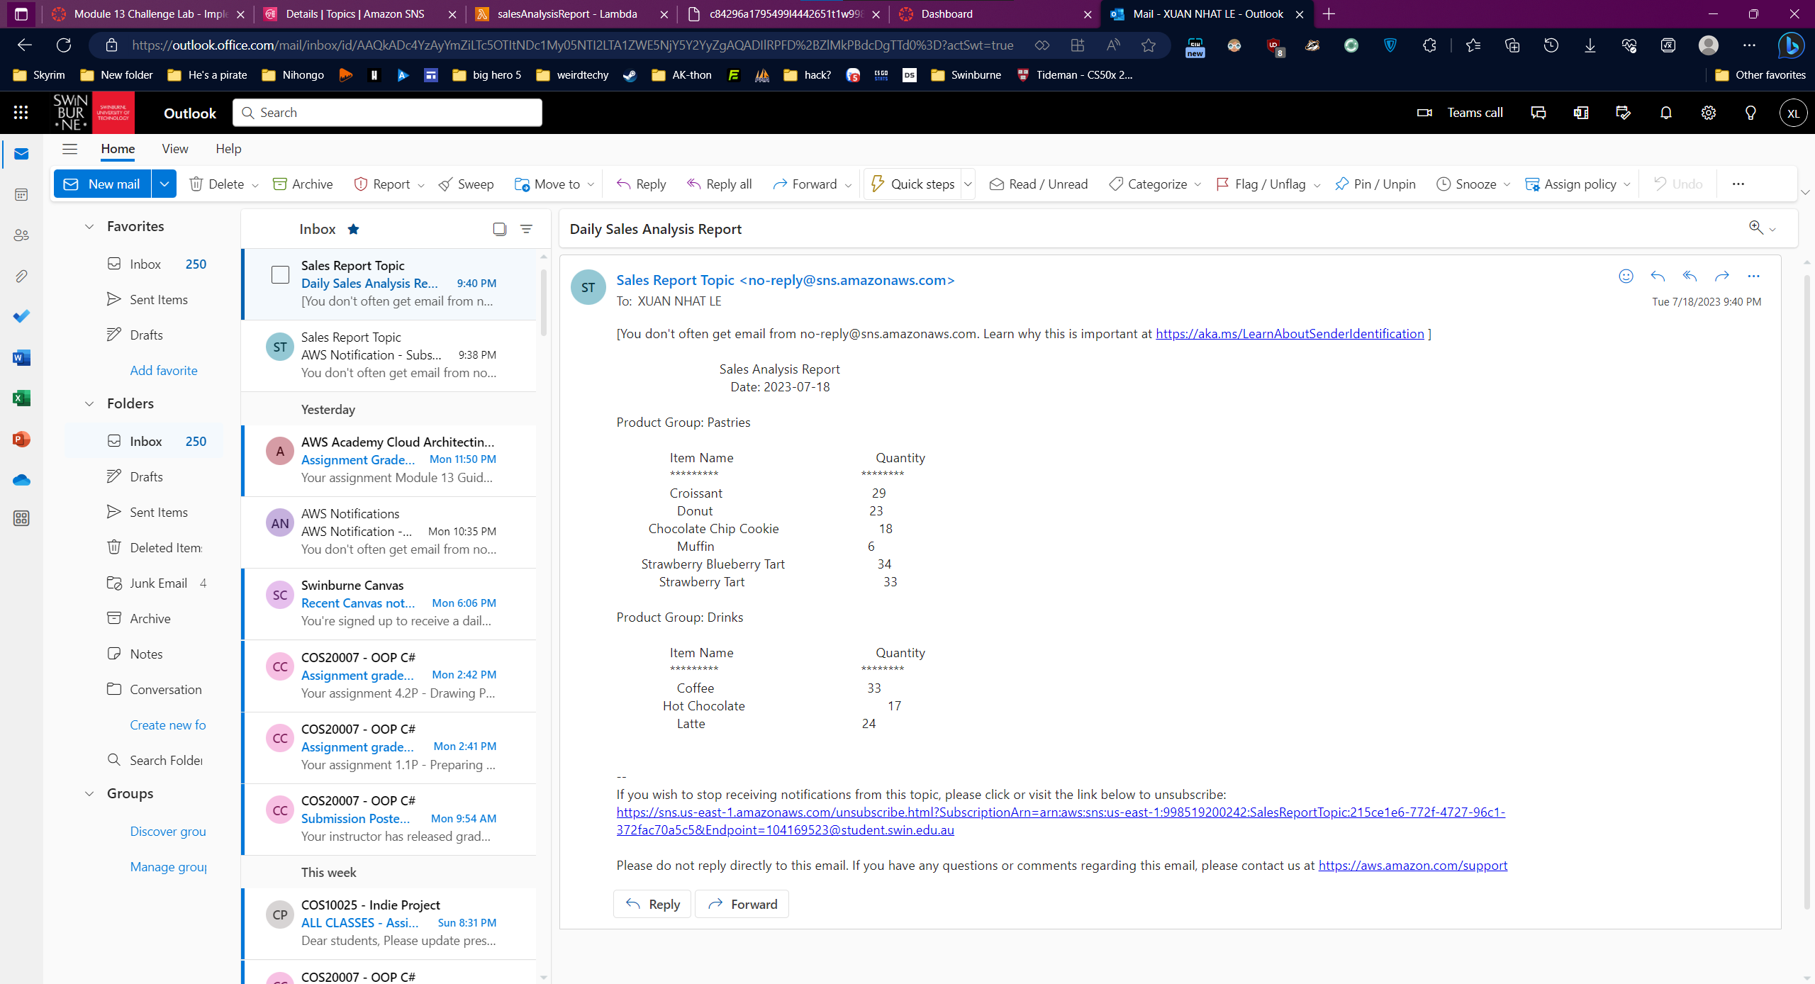

### Task 7: Setting up an Amazon EventBridge event to trigger the Lambda function each day

Create a rule

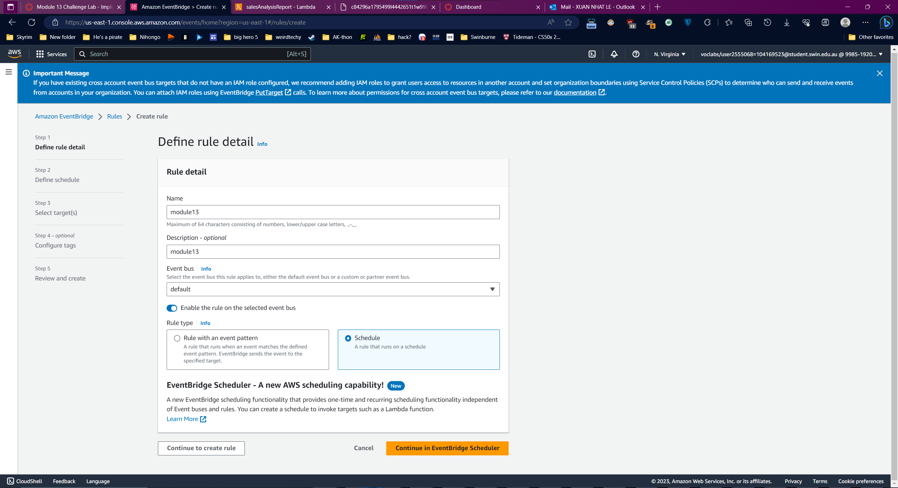

Pattern

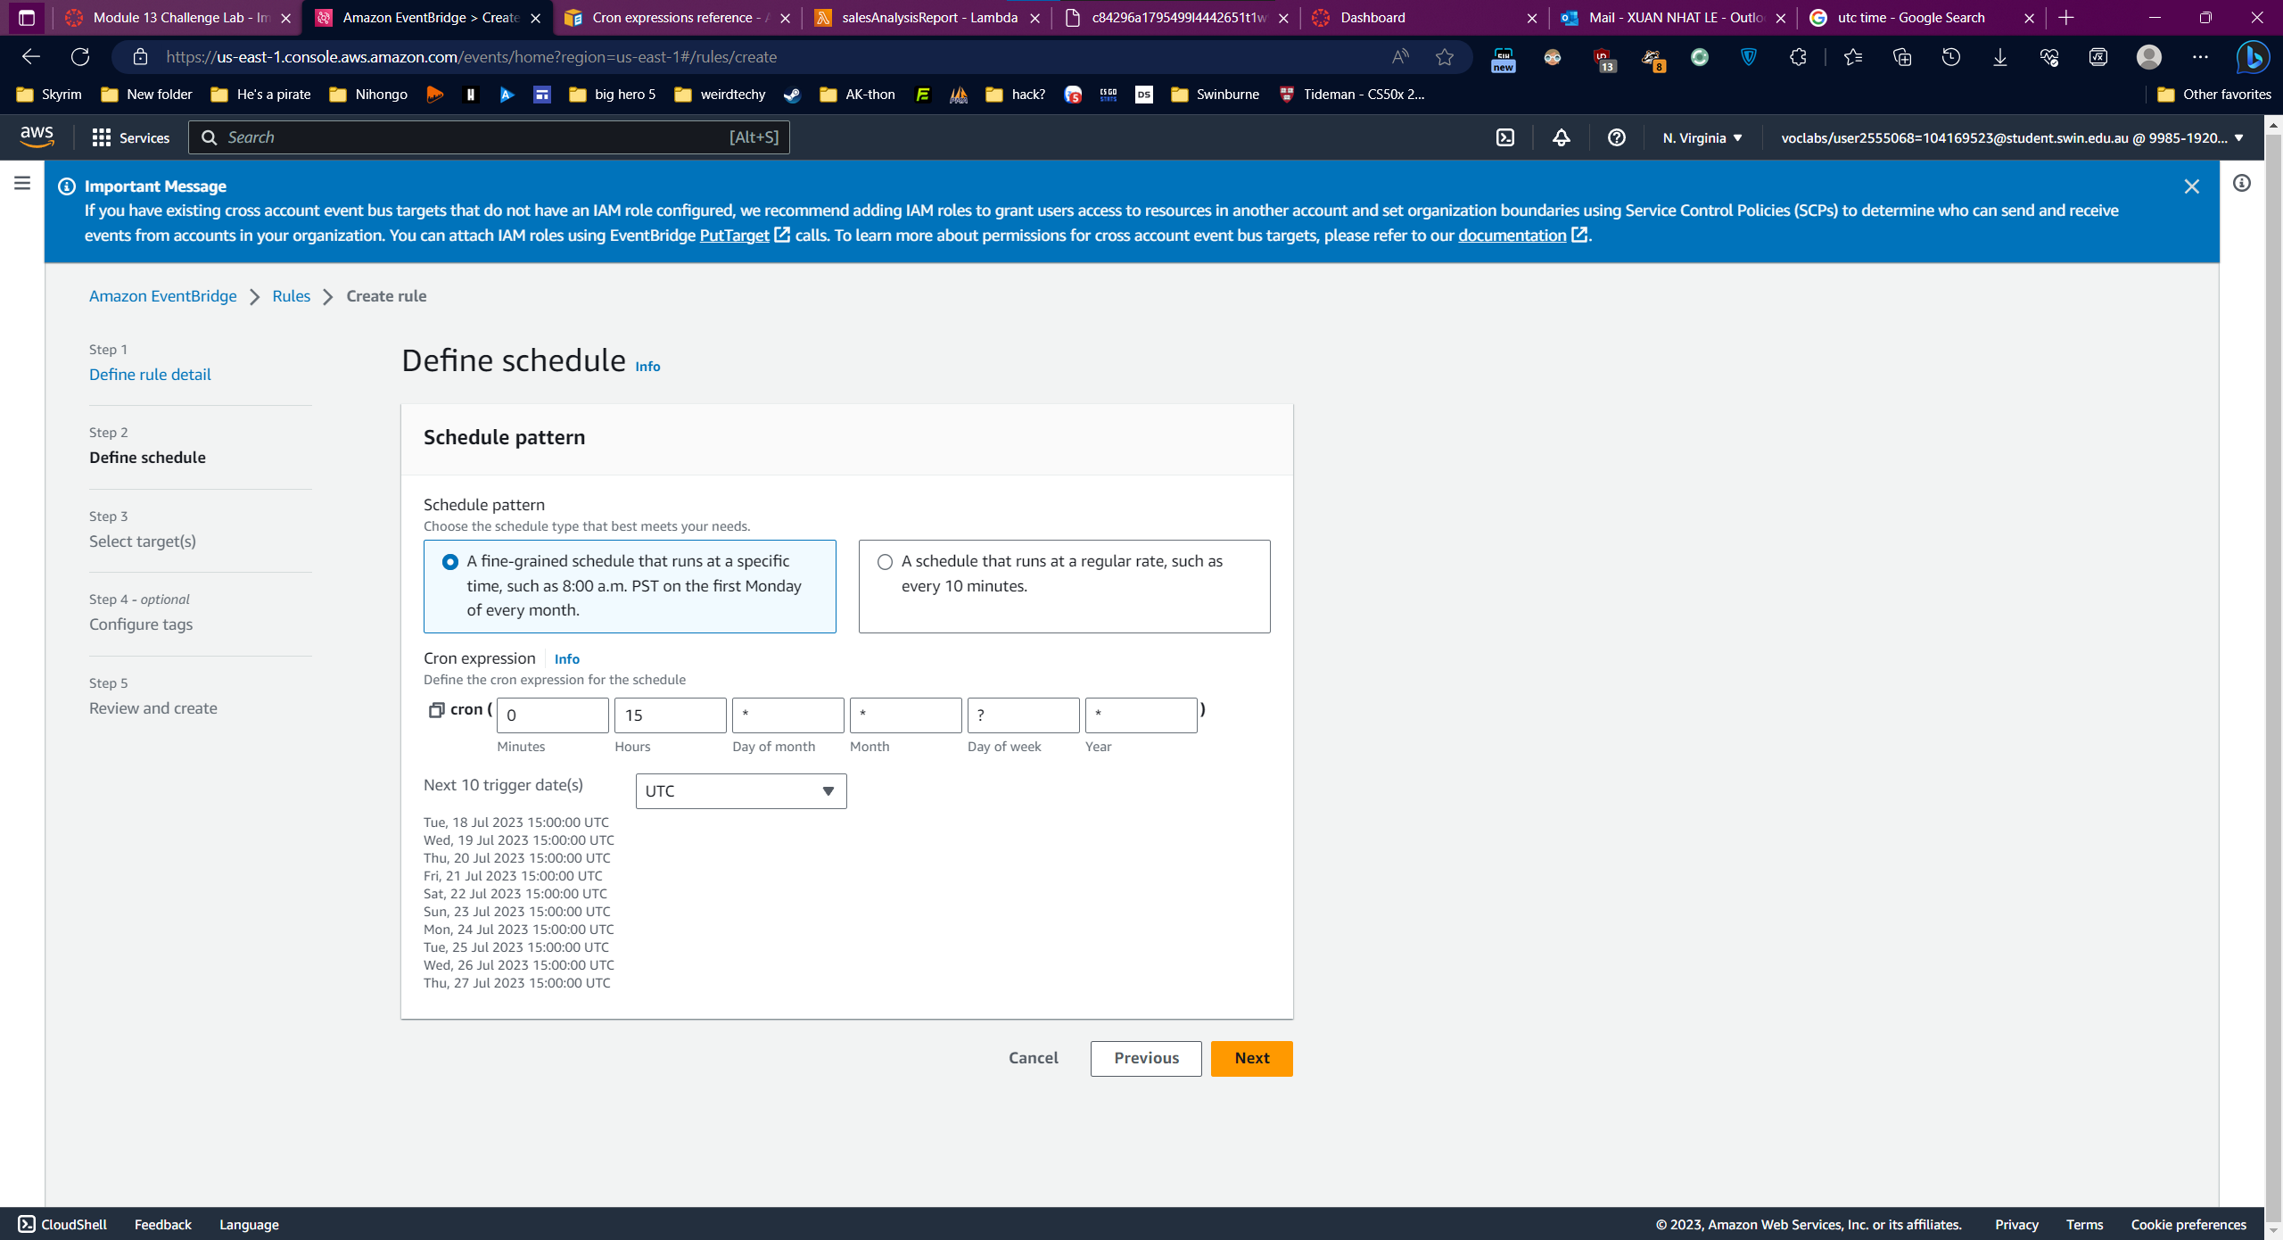

Target

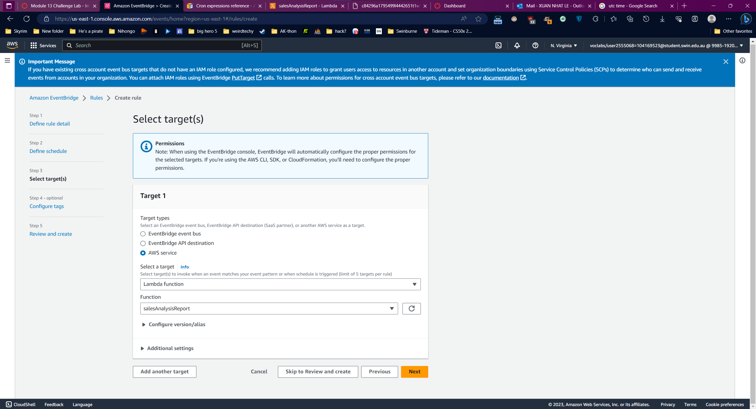

Success:

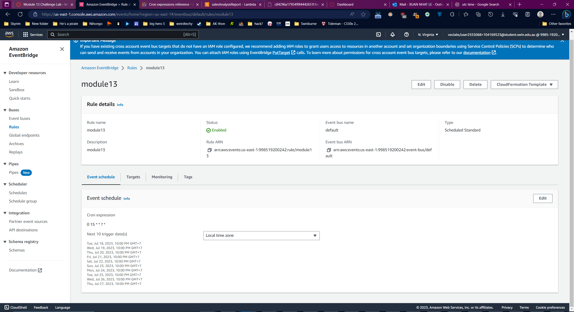

Mail:

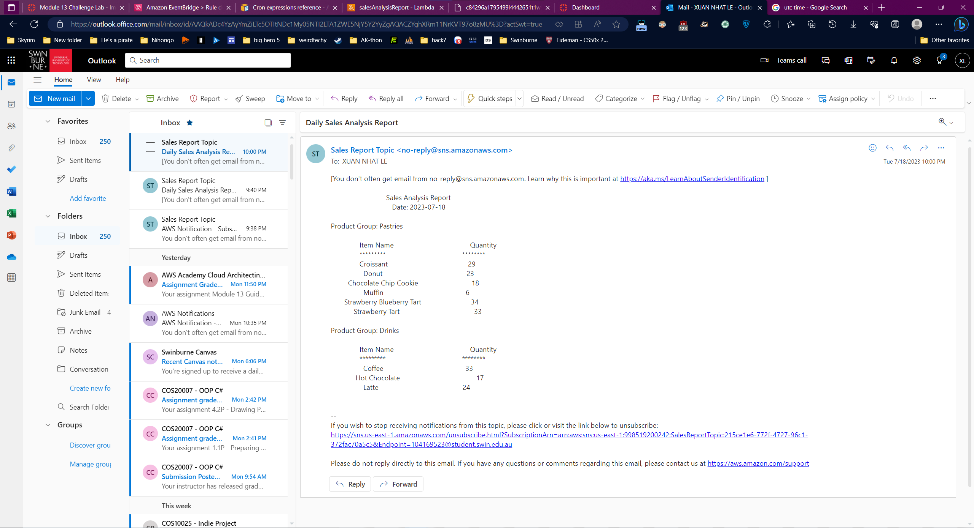

Question 5:

